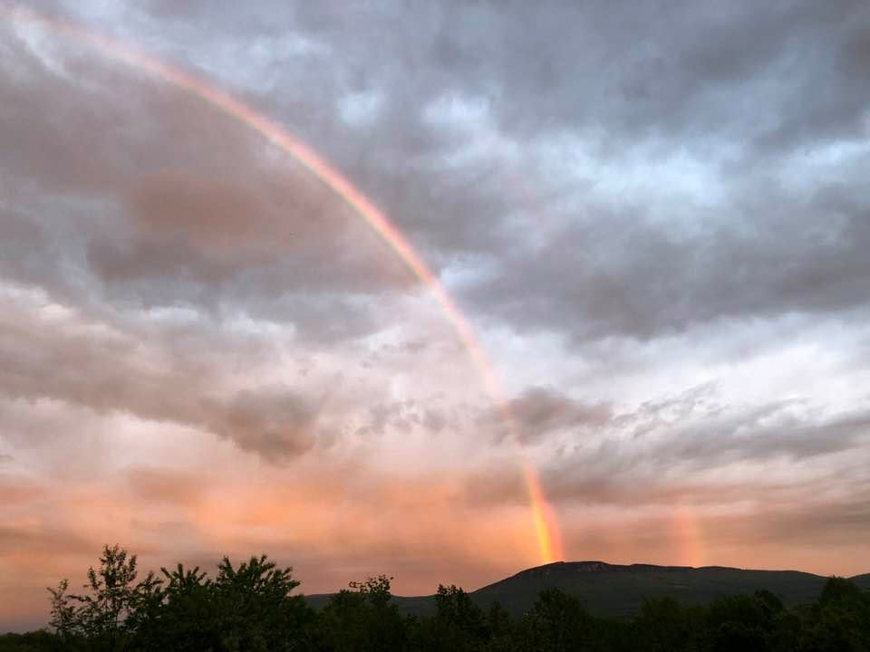
Message from Annukka Holland
Posted Dec 26th 2020
My dearest is free now, fly free and high Sangee! He went to heavenly home on Christmas Day! So grateful and honored to have shared path with you for many many years! Love you forever
https://www.facebook.com/photo.php?fbid=10222529076634636&set=a.10206125911445758&type=3
Tom Gold-Blyth:
Sending love to you Annukka and feeling great love for Sangee today. He seems to be everywhere xxx
Lisa Ramsey Sampair:
Sending Big hugs and Prayers. So So Sorry for your loss. He is not in pain any longer. He will always be watching over you. 🙏💕
Carrie Gold-Blyth:
Thinking of you dear Annukka and sending love your way 💕💫💜
Chuck Yoder:
Peace be with you....
Gerri Okano Nishida:
Dearest Annukka my prayers and love go out to you💕🙏. May Sangee Rest In Peace🙏 It was truly an honor to have known him💖Love you Sangee and Annukka
Yan Dong:
Dear Annukka, so sorry for our loss of a great master, but he is live in our heart forever. He is no pain and no suffer any more, in beautiful and peace heaven world. You take care and sending love to you and our heart with you too.
Leena Timoskainen:
Voi Annukka, lämmin osanotto ja enkeleitä ympärillesi❤
Mike Hylton:
Sending you love and prayers ❤️🙏 I am so sorry
Anthony Phelan:
Dear Annukka I am so sorry to hear this. You really have been in my thoughts, and how we have hoped for good news. He has been such an inspiration. With my love and admiration.
Debbie Dalton:
My love and prayers go out to you, Annukka Holland
Зоя Захарова:
I am so sorry
Bill Scheidt:
He transformed our lives in every way, and will be with us forever. The lives we live today are the legacy he leaves behind. Sending you love Nuke ❤️❤️❤️
Marina Hildegard Sesay:
💖
Cindy May Cooper:
My heart is filled with love and gratitude for San Gee, for you Annukka Holland and for our community, for all that we have shared together, for all the laughter, all the tears and all the lessons learnt. So much love to you at this time and wishing San Gee well on jis journey. Xxx
Ashleigh Zee:
Praying for you, Annukka Holland!
Bethany Earl:
Sorry for your loss he was an awesome person. He will be missed!
Richard Hofmann:
Sending prayers, Annukka.
Sonji Iona Anderson:
My condolences to you and the Golden Flower family. I wish you comfort and peace during this difficult time. I treasure the time spent and training with you and Sangee. You were very kind when my mom had surgery. Love y’all so much. <3<3<3<3
Mary Jani:
I’m so sorry Annukka ❤️🙏🏻
David Hoskins:
It was an honour to have met him.
A man who gave wisdom all over the world.
David Bolton:
Oh my...peace to him and to you .. he was a warrior for love and truth
Anne Tirronen:
Het spijt me voor je verdriet en kracht aan jou 💔
Yolanda Stith:
My thoughts and prayers are with you Annukka Holland.
Ann Rogers:
Praying for you and your family.
Laura Luykx:
Sending you love and heartfelt condolences as Sangee goes on to this next part of his journey.
Megan McGee Ingram:
Oh my. My dearest heartfelt condolences to you Annukka Holland. What a very auspicious day of passage for Master San Gee. "All we have is awareness..": he told me. It deeply impressed me and I hold my experience with you and the Golden Flower dear. Prayers to you and to Heavenly Way.
Simon Mills:
There isn’t an emoticon or words Annukka.
I always thought at some time we would meet again.
In this world 🌎.
It will have to wait until the next now.
Know you are loved 🥰 Nukes. Welcome here any time.
Simon Mills:
Love from Australia Sangee.
You live on in us. 💕❤️💕
Simon Mills:
Afbeelding kan het volgende bevatten: 2 mensen, staande mensen, lucht, boom, buiten, natuur en water
Danielle Clendenin Wall:
You are in my thoughts!!!! 😭
Els Verbeeck;
Sending lots of love & support to you Annukka. 💖 So sorry to hear that. Sangee was such a precious teacher. No words to express how grateful I feel for his teachings, the insight & wisdom he shared, all in a way of so much love, attention, joy, humor and so much more. A big blessing, a big privilege to have got him as teacher, healer and guide. So many blessed memories!
Fly free Sangee, you will always be in my heart! 💖
Meghan Prior:
I rarely go onto FB these days but just happened to pass through to check something on marketplace and saw your post. My heart feels so much for you Annukka. We plan to light a candle and chant the ancient mantras for him this evening. May peace be within and without as you journey through this event.
Kathy Grace:
I am so sorry for ur loss!
Bettye Barrett:
So so sorry Annukka...
Jerri Jackson Burtts:
I am so very sorry for your loss. I am praying for peace!!
Nigel Goulding:
Hey Annukka,
I’m deeply moved to hear of Sangee’s departure and send you love and light.
It’s been nearly 30 years since I met him and he made such a powerful, positive, transformative & lasting impact to my life.
I’m sad and grateful and sending you big warm hugs.
Rebecca Bryant Williams:
Fly free Sangee. Much love and gratitude for all that you shared with us. Love and light to you Annukka. He will be with you always.
José Mark:
Sangee would always make fun of me, look at that face while I am trying to ride a horse. Cheeky!
Afbeelding kan het volgende bevatten: 1 persoon, buiten
Oona Westerlund :
❤️
Ina Sabanoglu:
What a Graceful and Loving goodbye with this Golden Rainbow! He was a true Grand Master. I feel truely grateful that he was in my life too, and will be for times to come. I honour him in my prayers and lessons.
Sending Love and Strength to you Annukka Holland
Varpu Eronen:
Otan osaa! Paljon halauksia meiltä❤️
Louise Norvig:
❤️❤️❤️ he is in my heart forever with his laughter and playfulness. His wisdom and love. With tears in my eyes I am sending lots of hugs and love. All the best to you Nuke. And all the best to Sangee ❤️✨❤️✨❤️
Brigitte Lafrechoux:
Blessed be blessed be his soul and blessed be your Annuka. Only good memories of Sanguee xoo
Robin Lynne: So grateful for Sangee’s life and the love, joy and wisdom he shared with us all. Standing beside you as you navigate this loss, grief, love and rite of passage. Love you 🦅
Richard Jordan:
So sorry Annuka! He will be missed! Our hearts are with you.
Tatyana Seamon:
So sorry for your loss! 🙏🙏🙏
Merja Becker:
lämmin osanottoni !
Svetlana Nakata:
Annukka, so sorry!🙏
Konstantin Matveenko:
Annukka. So sorry. Love and memory from us.
Mary Ross:
I am so sorry.
Kari Foster Allison:
Peace be with you Annukka Holland. Sangee was an amazing being. I am so grateful to have met him and spent time with him, though i wish it was much more. Blessings.
Rick Berry: May his spirit be the essence of Peace & Tranquility🙏☯️
Colin Allured:
So much love and appreciation for you both. Fly away home great soul 🙏❤️
Ben Vanden Berghe:
Not enough space here on FB to express the importance of Sangee to my mother Maria and to me here in Belgium. The joy and happiness he brought in our home on the many occasions he visited and stayed in Oud-Heverlee. All my love to you too, Annukka, for being who you are. take care!
Susan L Hunt:
Thinking of you Annukka Holland - Sangee’s spirit will forever be with you - and he’s flying with Bobbie Bingham now! What a challenging year this has been.
Carla Verhaaf:
I am so sorry Annukka! Sending you all my love and light. And to Sangee, my endless and ongoing source of inspiration, adventure, love, light and power. I am so grateful and honored for his guidance, teachings and unconditional love on my life-journey. For me, Jos and so many people all over the world. My heart goes out as well to the whole Heavenly Way & Golden Flower Family and all the people sharing his spirit and surrounding, supporting him and you with their love and light.

